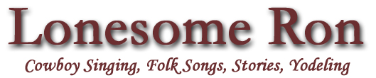

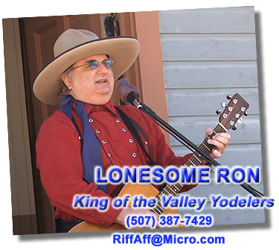  Photo by Tim Madson | Lonesome Ron is a singer/songwriter and a  recording artist who presents western music in story and song. He plays guitar & banjo and adds in some fine country yodeling.  Lonesome Ron has performed with some of the top names in country music such as Jean Shepard the Queen of Country Music, Donna Douglas of the Beverly Hillbillies and Les Gilliam.  He has also shared the same venue with acts like Jan & Dean, Marie Osmond, Boxcar Willie, the Kingsmen and Gary Lewis.

Over the years, Lonesome Ron has been featured at many

old west and historical events including:

- Northfield, Minnesota’s Defeat of Jesse James Days
- Spirit of the West Festival – Sioux Falls, South Dakota
- Laura Ingalls Wilder Days in Walnut Grove, Minnesota
- Younger Brothers Capture– Madelia, Minnesota
- Jesse James Farm – Kearney, Missouri

For an enjoyable toe-tappin’ time
Call Lonesome Ron

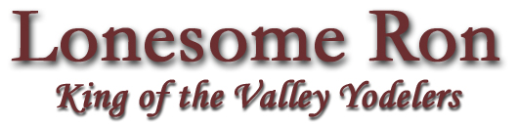

(507) 387-7429
RiffAff@Micro.com
www.mnriv.com/cowboy.html

